**Smoke-Free by Team White N Black**

Guan Wei, Kee Yang, Joycelyn, Heather, Daniel, Ray

**Problem**

Smoking is the number 1 cause of preventable death in the world. It kills 5.4 million people a year worldwide, accounting for 10% of adult deaths. According to the Ministry of Health, smoking causes 2000 Singaporeans to die prematurely each year. Importantly, smoking-related diseases like cancer, heart disease and stroke are Singapore’s top killers (Healthhub.sg website).

The MOH study also explains the huge social cost of smoking. Every year, at least S$600 million is lost as direct healthcare costs and lost productivity from negative health impacts of smoking.

**Project Mission**

To build a strong community of ex-smokers, current smokers and medical professionals where individuals will be encouraged by others to quit smoking. Users can share information, receive social support and be accountable for their progress.

**Key Features**

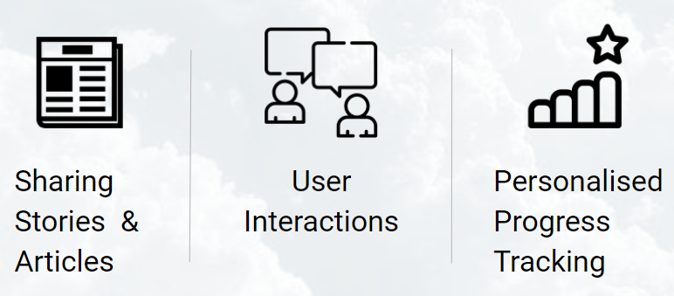

These are the three main features.

1. Users share stories and articles, motivating each other to quit, and learning more about the health impacts of smoking.
2. Users must be able to interact with each other through comments on stories and articles. This encourages active participation in the discussion.
3. Personalised progress tracker would create accountability for a smoker who is trying to quit.

Other features are modeled in the Use Case Diagram below**.**

**Use Case Diagram**

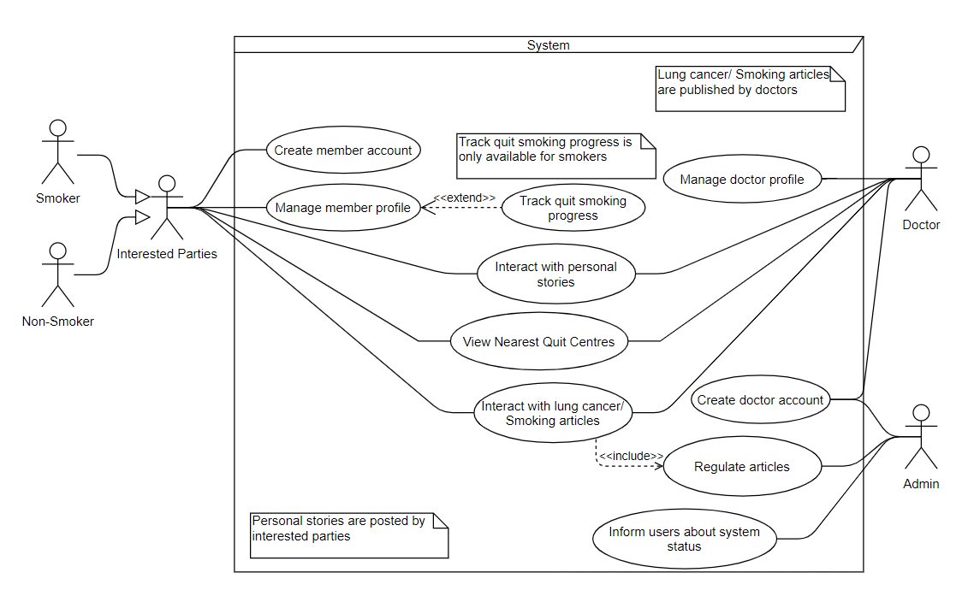

In addition to the three main features shown above, each user must also register for an account to participate on our website. This is for personalisation and to enjoy the features such as creating stories, comments, replies and tracking their progress.

As inter-user interaction is core to our platform, we allow interested parties and doctors to freely comment and reply, and to check up on each other’s profiles. We hope to foster a sense of community which would help smokers find the support they need to quit.

Doctors are screened during sign up by the admin to ensure credibility. Furthermore, the articles can only be written by doctors. These articles are also subjected to approval by the admin to maintain relevance and credibility of our website.

View nearest Quit Centres is accessible for all users. Any user, including those not logged in, can view the Quit Centres in Singapore, populated using Quit Centre data from data.gov.sg. The user can then opt to view the nearest Quit Centres based on their current location. This makes it easy to find Quit Centres nearby, encouraging users to visit one, if they need the help.

**Explanation of Class Diagram: Classes related to Story & Article**

There are several classes related to the creating and interacting with stories/articles. Firstly, Content is a generalisation of Stories and Article since they have attributes in common. Comments can belong to one Story or Article, or as a reply to another Comment.

StoriesTag and ArticleTag are part of Stories and Article respectively.

StoryController, ArticleController and TagController update their respective entity classes and their respective UI.

**Sequence Diagram: Interacting with Lung Cancer/ Smoking Articles**

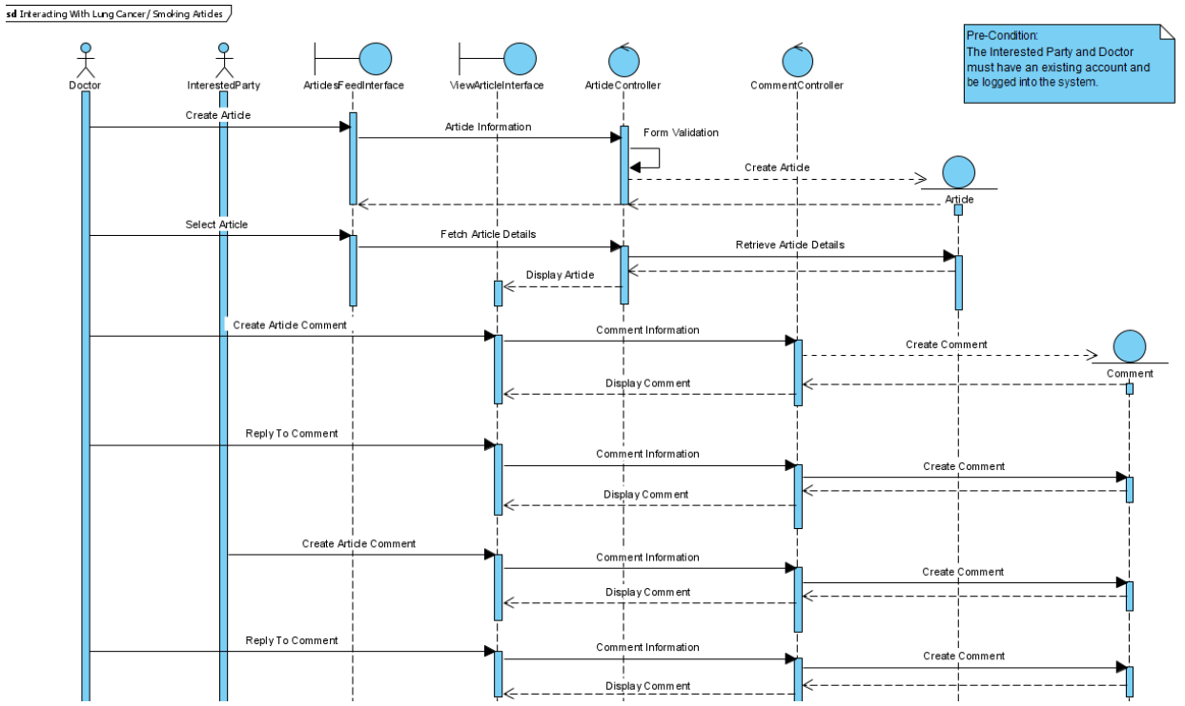

In this sequence diagram, we wanted to understand the method calls for all the use cases that will create, or interact with the Article model. We have the Doctor user being able to create and view articles, create comments on an article, and reply to other comments.

The InterestedParty user is able to only view articles, create comments on an article, and reply to other comments.

Any request to create or view an article goes through the ArticleController first, before it is sent to the Article model. Likewise, any request to create or view a comment goes through the CommentsController before it is sent to the Comment model.

**System Architecture: Model-View-Controller**

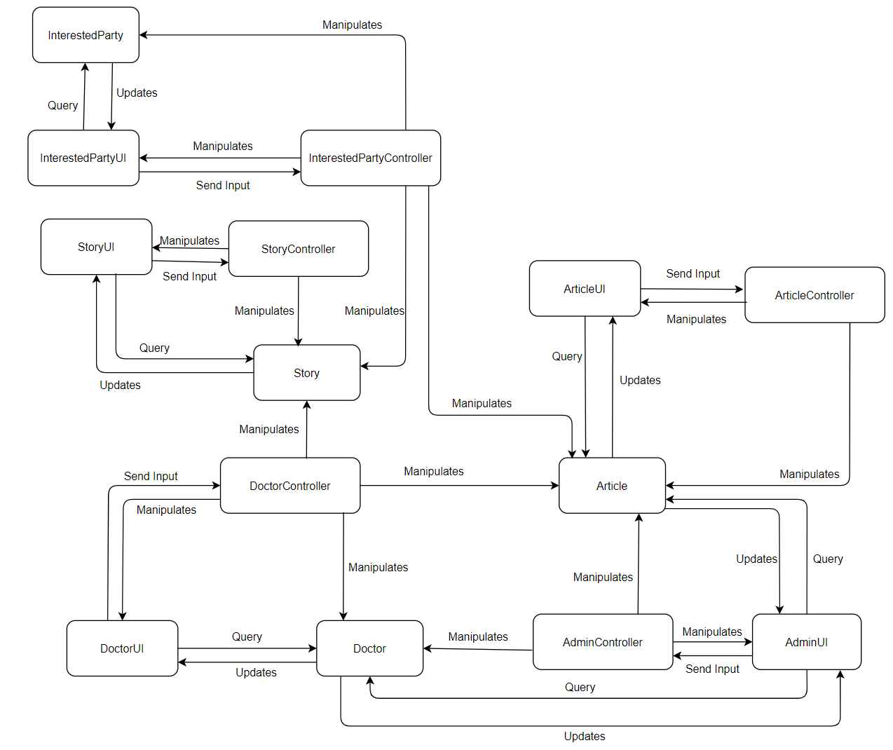

We chose the MVC framework implemented in Microsoft ASP.NET MVC 5 because it was lightweight and extendable. We could add plugins when we needed them. By repeating the MVC pattern for each entity class, we get something like the above diagram.

As every entity has its own controller and view, we separate the concerns of the boundary, controller and entity. At the same time, it would be easy to add more functionalities by adding new MVC patterns and linking them up in the diagram.

Another benefit to such object-oriented design would be the ability to work on multiple parts of the code at the same time without conflict as the classes are appropriately encapsulated.

**Project Timeline**

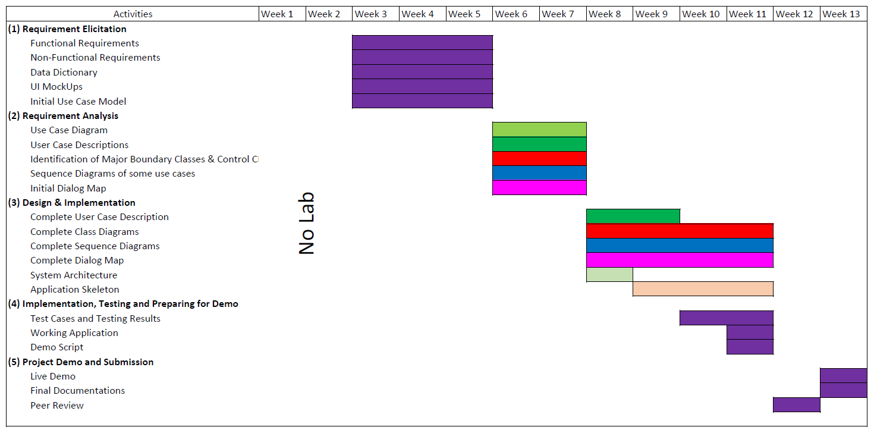

This is our simplified Gantt Chart. We spread the project over the entire semester to keep a consistent pace of work. This also allows for some leeway when certain parts overrun their deadlines.

Each colour corresponds to a portion of the project. Purple is a general label for all the generic tasks. As you can see, each component of our project is worked on, in stages such that related components are worked on at the same time.